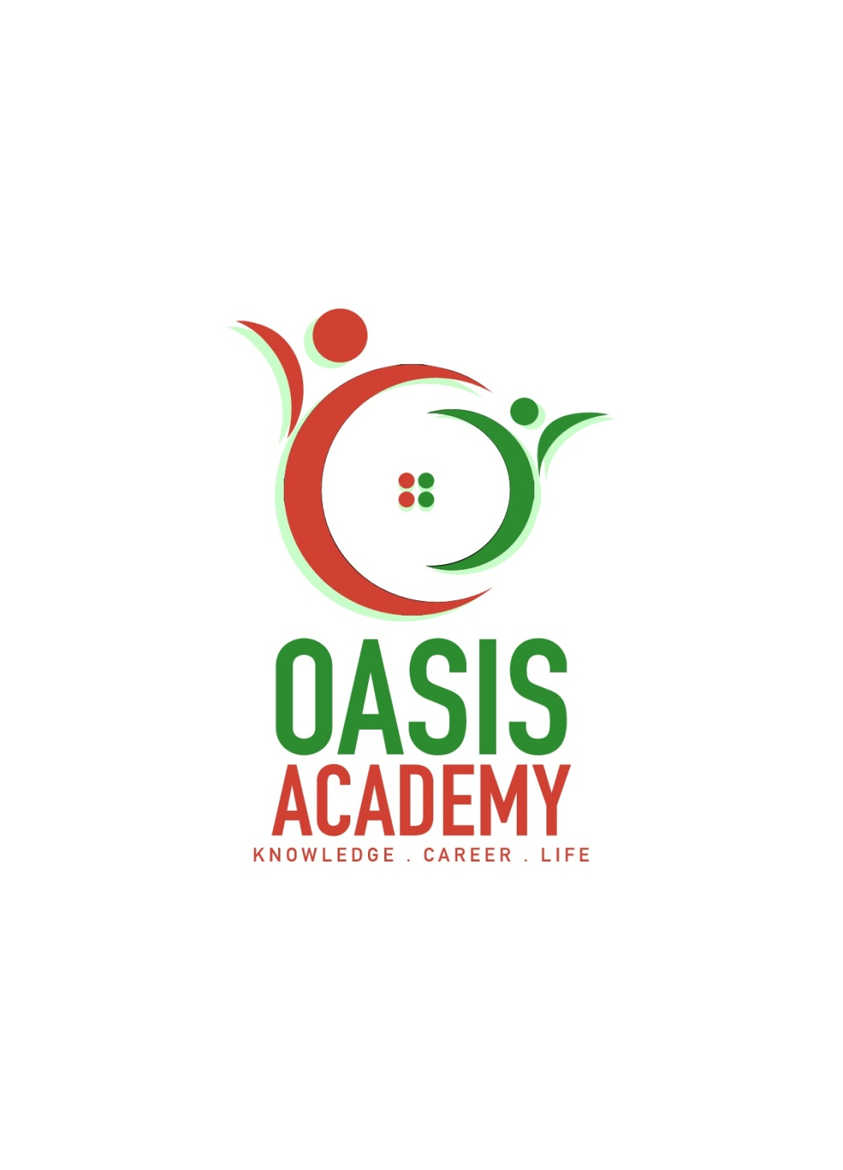

Name: **LOW JUN LING**

Login ID: **lowjunling@oasis-portal.com**

Course title: **Tourism and Hospitality**

Subject Code: **BHM04**

Submitted date: 11/09/2017

**Table of Contents**

|  |  |  |
| --- | --- | --- |
| No | Details | Page |
| 1 | Executive Summary | 2 |
| 2 | Introduction | 3 |
| 3 | Assignment Question |  |
|  | Part 1 | 4 |
|  | Part 2 | 5-6 |
|  | Part 3 | 7-8 |
|  | Part 4 | 9-10 |
| 4 | Conclusion | 11 |
| 5 | References | 12 |
| 6 | Appendix | 13 |

**Executive Summary**

In this module, I covered the topic about the Tourism and Hospitality. In starting part, we can see the introduction of Tourism and Hospitality .What is Tourism and Hospitality relationship in business operation? In first questions, I studied brief in hospitality industry and will explain the define Tourism Hospitality. In the second questions, I will brief explain all types of tourism categories in detail and what brief on different? Third questions, I have understood the concept of Lodging and Accommodation in hospitality industry and also types of hotel accommodation. Finally, I will explain topics on the entertainment industry in hospitality management.

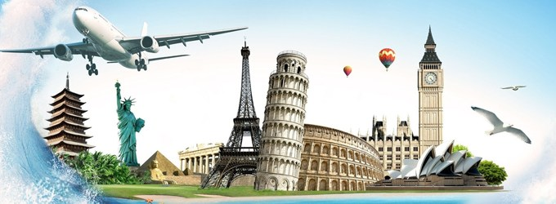

***Figure 1: Pricing Strategy For Tourism Businesses***

**Introduction**

Tourism is a complex integrated activities, which include eating, living, traveling, travel, shopping, entertainment and many other people in the tourism activities are not just walking tour, more is to experience the tourist novelty Cultural environment, taste the flavor of food, buy a distinctive native products. This series of activities is not a single tourism sector can be completed, the need for support of different departments. For example, the hotel industry to provide visitors with a comfortable rest environment, the transport industry to provide visitors with convenient means of transport. Tourism to food, health, architecture, culture and education, transportation, agriculture and forestry and other departments closely linked. Correspondingly, the tourism industry has developed and these departments have been developed. The tourism activities are made up of different tourism projects. The type of tourism has a comprehensive modern tourism type divided by geographical area, with international tourism and domestic tourism. Division, group travel, FIT travel, package travel, self - help travel etc. Travel refers to people who use their own economic means, for entertainment, health care, rest, cultural activities or other similar reasons to travel voluntarily. There are also some activities for leisure, business and other purposes, leaving their habitual environment, going to some places and staying in some places, but not more than a year. Tourism can be a leisure time for people who are temporarily recuperating, educating, expanding knowledge and interacting, participating in organizational activities, changing the relationship and role, and so on. Tourism is also a good means of sports and cultural rest, it has a tour, visit, march and other forms, can be walking, you can also use a variety of modes of transport. It can increase knowledge, expand their horizons, exercise.

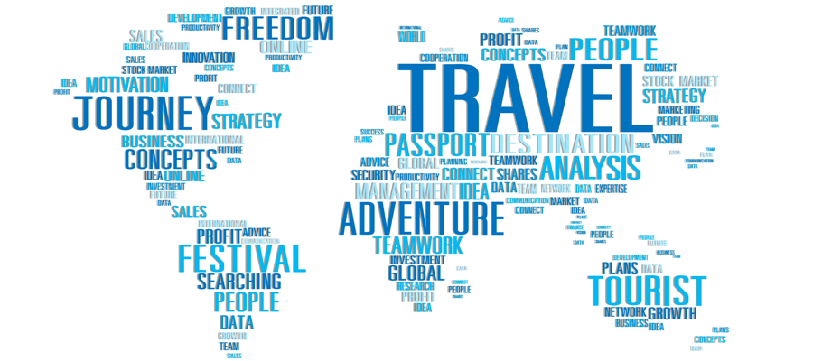

***Figure 2: International Tourism Business Management***

**Assignment Questions**

**Question 1**

Define the Tourism and Hospitality.

Explain your understanding about Hospitality industry.

The purpose of the tour is to visit a country, such as entertainment, vacation, health care, research, religion, sports, business, family, meeting, etc., in order to stay for more than a day of short trips. Tourism is the sum of the actions and processes that seek cultural differences and the resulting intercultural space of social behavior, relationships and influences. Tourism is a short - term special way of life for modern social residents. This lifestyle is characterized by off-site, amateur and enjoyment. Tourism is a social and economic situation under a socio-economic phenomenon, is the time to 24 hours of entertainment for the main purpose of tourism and temporary stay caused by the sum of all the phenomena and relationships.

The hotel industry is booming in the industry, with countless categories, but customer service is a common factor in all areas of the industry. So for the tourism industry, the hotel industry is a wide range of services, because there are including accommodation, event planning, theme parks, transportation arrangements, cruise and other tourism industry. Modern hotel refers to the provision of integrated services for customers to provide accommodation and catering services. The hotel is equipped with facilities and facilities, through the waiter to provide the necessary value for the guests, so the hotel is a service business. The hotel's foreign talent is able to accommodate foreign guests, which is the basic character of the hotel. There are two kinds of foreign guests entering our country: one is the social status or political status of high-profile people, the other is a very strong consumer traveler. They went to our country, asked the reception to reach the standard of living. As a result, has adapted to the needs of the international tourism market hotel to meet the life of foreign guests as a benchmark. Hotel in the equipment facilities, service level, quality of personnel, management and other aspects of the international market standards as the basis, from the hotel's tourist hotel level and level reflects the foreign. The hotel is a business. The hotel is engaged in accommodation service activities, providing comprehensive services for the guests, in accordance with the laws of independent management, independent financing, and economic organization independent accounting.

The hotel industry is a wide range of business groups that provide services to customers. It focuses on customer satisfaction and provides them with a specific experience. The hotel industry is unique because it relies on free income and free time. Different areas of the hotel industry, is a strong concern to customers, providing a level of service and industry economy.

**Question 2**

Brief on different type of Tourism categories.

Define Tourism.

* **Leisure Tourism**

Leisure travel is a leisure, relaxation, vacation as the main purpose of a new form of tourism activities, tourism is an alternative product. With the economic development and social progress, accelerated pace of life, people's quality of life requirements are getting higher and higher. At the same time, people's income levels continue to improve, more and more leisure time, which for recreational tourism to create the conditions. Spa, beach, beach, mountain skiing, etc. is a traditional holiday destination. In recent years, the village near the city, the resort has become a popular holiday destination.

* **Religious tourism**

Religious tourism is a religious-oriented tourism. There are three major religions in the world, namely, Christianity, Buddhism and Islam, where the number of believers reaches billions of people. Many people go to pilgrimage or participate in various religious activities every year. Especially the Muslims, every year thousands of people from all over the world went to the holy places of the Holy Land in Mecca.

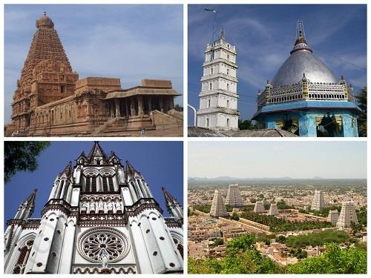***Figure 3:*** ***Religious Tourism news***

* **Sports Tourism**

Sports tourism is to participate in and enjoy the domestic and international sports events as the main purpose of the tourism activities. In today's society, sports tourism has become an important part of tourism activities, skiing, mountain climbing, rafting and so are the form of sports tourism. The world's largest sports event, attracting thousands of athletes, coaches, journalists, fans and sports enthusiasts, is the world's largest sports event, especially the Olympic Games and the World Cup. Sports and tourism have the same purpose is to establish a bridge of communication between different cultures, lifestyles and traditions.

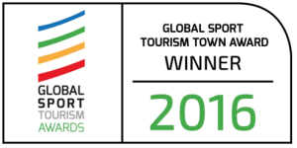 ***Figure 4:Global Sport Tourism Town Awards***

* **Educational Tourism**

The study tour is a tourism activity aimed at cultivating the culture of a foreign country. In recent years, there are tourists from around the world to study tourism has become a fashion, every year a large number of large and medium-sized students to use winter and summer vacation to other countries while traveling, while learning the local language, culture.

* **Business Tourism**

The main business tourism activities include meetings and exhibitions. Business travel is based on various types of business activities as the main tourist destination. Business travelers on the accommodation, transportation, food and other are higher requirements.

* **Nature Tourism**

Enjoy the breath of the natural environment contact wild animals, explore new things, including ecotourism. This is part of the area of the natural landscape of the tour. Such as camping, hunting, fishing and visiting the park. These experience visitors are interested in the diversity of natural and cultural resources. They want what is real, they want to immerse themselves in the rich natural, cultural or historical experience.

* **Active Tourism**

The event tour is a new tourist concept, and active tourism is designed to combine entertainment, education, and benefits for visitors and visits to the land. Active tourism and ecotourism and natural tourism have many similarities, but also the integration of some action and adventure tourism activities. There will be goals, such as climbing, skiing, scenery, walking or snowboarding.

* **Health/Medical Tourism**

Medical travel refers to travel to countries other than their own medical care. Those less underdeveloped countries to major medical centers of high developed countries, in their own country, can't be treated by people. Health tourism is a wider travel period ,focusing on health care and using health care services. Health tourism is a related area.

**Question 3**

Describe the lodging accommodation and types of Hotel accommodation.

Lodging Accommodation is a place of residence, like people who travel abroad, need rest, food and safe place. Lodging accommodation like a home, a roof ,not afraid of rains thunder. Lodging accommodation is in hotels, motels , private homes and lodges. Accommodation is an indispensable part of all destination tourism development, aiming to provide quality and range of services to tourists other than tourists Reflecting and influencing the range of visitors to the location of tourism in the local and national economic contribution of the overall play Level of action. The hotel is by size, location and facilities, the hotel is usually rated as one star five star. There is a class hotel. The facilities and services of these hotels can meet the basic needs of the guests, the general price is cheaper, mostly for the economy hotel. There are three hotels. This kind of hotel facilities are well equipped, well, the service is complete, the price is moderate, is the general tourists prefer the hotel. In addition, there are five-star large-scale hotel, the service is more complete, facilities, equipment, more luxurious hotel.

* **Backpackers Hostel** - This is ideal for budget travelers and backpackers, which is an inexpensive accommodation with shared bedrooms and public facilities. The price is the cheapest.
* **Lodge** - Usually made of nature, made of logs, wood or other natural materials. rural huts are small holiday homes, which are generally in less developed countries, some people who are accustomed to living in the city, want to experience the rural life of people, which is one of the very good vacation options.

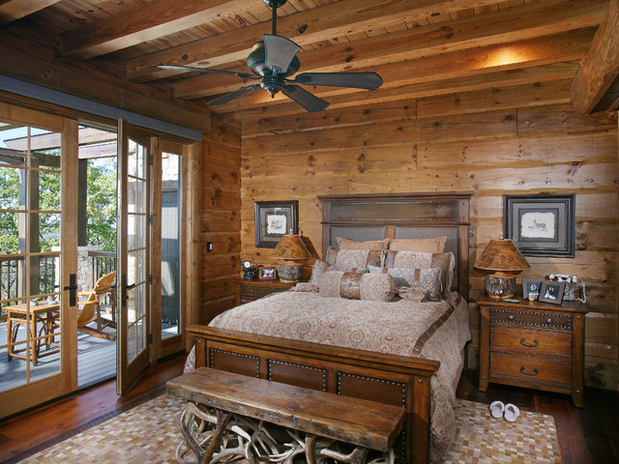 ***Figure 5:*** ***Wild Turkey Lodge Bedrooms***

* **The boutique hotel** - decorated in a unique style of the hotel theme, the size of the boutique hotel intimate, focused on the guests, to provide them with high quality personality experience.
* **Villa** - Villa is a luxurious country house, usually a village house consisting of several buildings or structures, relatively wealthy people to buy, used to vacation and party. It may also be a separate house or semi-detached villa in other places
* **Tent** - is used outdoors, generally go camping, mountain climbing, need a resting place to sleep, the tent is made of fabric portable shelter, supported by one or more stents.
* **Independent theme accommodation** - lighthouse, underwater hotel, tree house, houseboat, castle, cartoon theme hotel, cave, plane hotel.

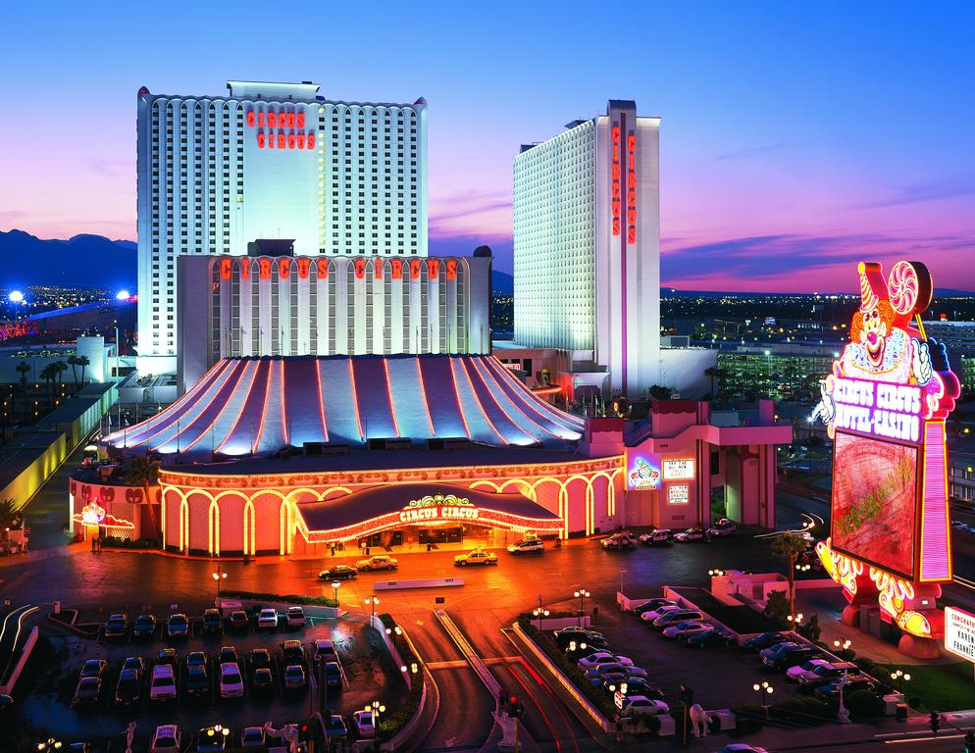 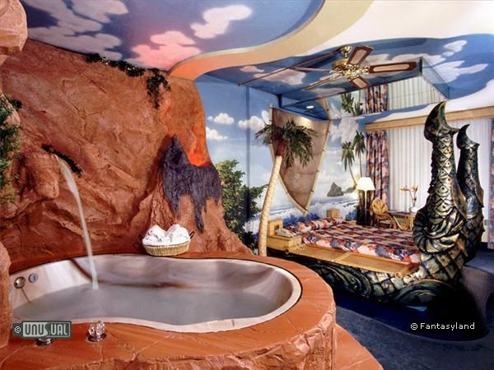

***Figure 6:*** ***Casino theme hotel & Cave theme hotel***

**Question 4**

Explain the Significant of Entertainment in this industry,

Entertainment is to achieve the purpose of regulating the body and mind, to restore physical strength and cheer the spirit of the use of leisure time, in a certain venue and conditions involved in the leisure and recreational activities. Entertainment can bring us fun, enjoy, laughter, pleasure. Entertainment is a kind of activity that keeps the audience interested and interested, although people's attention is controlled by different things, because each person's preferences are different, so most forms are recognizable and familiar. People can also create their own entertainment, such as their spontaneous invention of the game, or actively participate in what they feel interesting activities, and some are when they are sports as a hobby. Recreational activities can eliminate fatigue and achieve labor reproduction. Most of the recreational activities need to have a social environment, competitive atmosphere, the need for specialized venues and services, which also carried out recreational activities for the entertainment business has brought great economic benefits. Entertainment is an important part of our trip, and if you travel less fun and no entertainment, then you may not be able to fully enjoy your trip. In order to successfully run the hotel business, it is important to have as many recreational activities as possible.

The following are recreational activities that can enhance the experience:

* **Marinas**

Marinas is one of the most popular places. Many people like to use to hold fun parties. You can enjoy, can sing, dance, play games, or in a private yacht with your friends get along, put down the work pressure, enjoy the best of everything in life.

* **Sports and gaming**

Sports and games are the things that most travelers will be looking for. Like a bike, swimming, are very enjoyable sports. The casino is now one of the many favorite games, so there are a casino in some of the larger luxury hotels. And other similar activities are becoming an indispensable part of the hotel industry.

* **Cruise**

Cruise service has also become an important part of the hotel industry. The cruise is all-encompassing, including a casino, swimming pool, buffet food, so you enjoy the luxury in the blue ocean to spend a day.

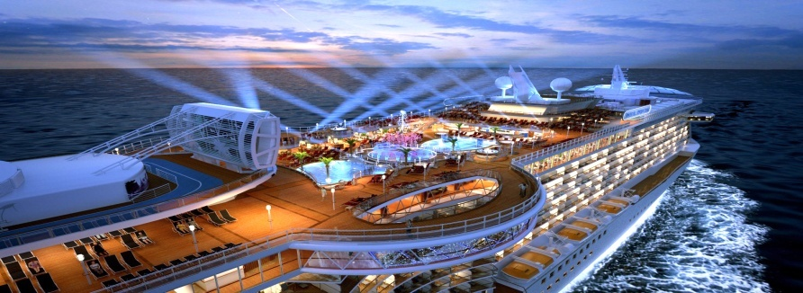***Figure 6:*** ***Cruises***

* **Nightclubs**

Nightclub is one of the most popular places for young people. You can enjoy the music in your favorite dance, with some friends like to drink a happy, enjoy life. That's why the nightclub is important in the hotel.

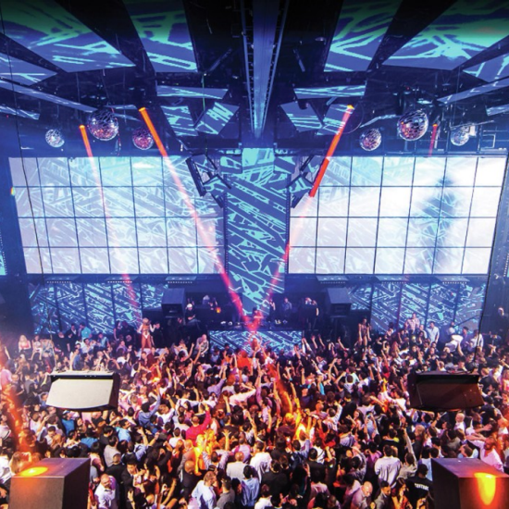

***Figure 6:*** ***Light*** ***Nightclubs***

* **Bars**

Sitting next to the table and talk to your friends and then taste a few glasses around the beer, wine, spirits, cocktails, etc., always refreshing experience. This is why the bar has become an indispensable part of the hotel industry entertainment industry.

**Conclusion**

In this assignment of Tourism and Hospitality, I learned a lot about Tourism knowledge. Travel refers to the use of their own economic means, for entertainment, health care, rest, cultural activities or other similar reasons to travel voluntarily. On the first question, tourism is to seek cultural differences and social behavior, but also modern people's short-term lifestyle. The hotel is a business that provides comprehensive services for the guests. In this conclusion of first question, we can see that the tourism industry is a very attractive service industry and the key to helping the country to attract tourists is to drive the country into a tourist And business destination one of the key industries. In the second question, we can understand many different types of tourism categories. Such as leisure travel, religious tourism, sports tourism, educational tourism, business travel and natural tourism. In the conclusion of the second question, in different tourist categories we can understand a lot of different ways of tourism, in fact, the purpose of tourism is to have a good rest, when the goal, but also to achieve the purpose of complete relaxation. In the third question, the accommodation and type of hotel accommodation are described. Accommodation is a place to live, but in every country or place, there will be such a different place to live. We can choose the accommodation we want to live with our favorite or economic ability. Coupled with the last question, I understand the importance of entertainment in this industry. Entertainment can bring us fun, enjoy, laughter and happy. So of course in the tourism industry can't be less entertainment. The entertainment industry is an indispensable part of the tourist hotel.

**References**

## Marketing Management Blog,(2015),*Pricing strategy for tourism businesses* , RETRIVED FROM <https://mpk732t22015.wordpress.com/2015/09/15/pricing-strategy-for-tourism-businesses/>

## UCB,(2017), *International Tourism Business Management*, RETRIVED FROM <http://www.ucb.ac.uk/our-courses/undergraduate/hospitality-tourism-and-events/international-tourism-business-management-ba-(hons)-fda.aspx>

1. Bled**,(2016),** *In London, Bled was awarded the distinguished Global Sport Tourism Town for 2017 designation*, RETRIVED FROM <http://www.bled.si/en/news/2016/11/260-In-London-Bled-was-awarded-the-distinguished-Global-Sport-Tourism-Town-for-2017-designation>
2. Purzuit.com,**(2017)***Religious Tourism*, RETRIVED FROM <http://religious-tourism.purzuit.com/>
3. Booking.com ,hotel ,RETRIVED FROM <https://www.booking.com/hotel/us/circus-circus.zh-cn.html?aid=356991;label=gog235jc-hotel-XX-us-circusNcircus-unspec-sg-com-L%3Azh-O%3AwindowsS7-B%3Achrome-N%3AXX-S%3Abo-U%3AXX-H%3As;sid=f611e2a976681f4ffa47ec90f0b128d5;dist=0&sb_price_type=total&type=tota>
4. Pinterest.com, GREAT Hotel Rooms, RETRIVED FROM <https://www.pinterest.com/daisycook21/great-hotel-rooms/>
5. My way holiday, Cruises, RETRIVED FROM <http://mywayholiday.com/category/cruises/>
6. Mandalay bay ,Light nightclub , RETRIVED FROM <https://www.mandalaybay.com/en/nightlife/light-nightclub.html>
7. Sha Zabala-Batin **,(2015**) ,Lodging Accommodation, RETRIVED FROM <https://www.slideshare.net/charliezabala7/lodging-accommodation>
8. Boomer and senior travel**,(2012)**What are the Different Types of Accommodations? ,RETRIVED FROM <http://www.boomerandseniortravel.tv/2012/03/06/what-are-the-different-types-of-accommodations/>
9. Wikipedia , **(2017)** ,Entertainment ,RETRIVED FROM <https://en.wikipedia.org/wiki/Entertainment>
10. Luxury accommodations ,(**2011-2017**), Understanding The Different Types Of Accommodation In Tourism, RETRIVED FROM <http://www.luxuryaccommodationsblog.com/post/114961446726/different-types-accommodation-tourism>
11. Altin Baku **(2013**), The Different Types of Tourism, RETRIVED FROM <https://www.slideshare.net/ALTINBAKU/the-different-types-of-tourism>
12. Wikipedia **,(2017**), Tourism , RETRIVED FROM <https://en.wikipedia.org/wiki/Tourism>
13. All about careers, **(2017**) Hospitality and Tourism , RETRIVED FROM <https://www.allaboutcareers.com/careers/industry/hospitality-tourism>

**Appendix**

